AI Ready ASEAN Youth Challenge 2026
Project Proposal

“Warm Hands”

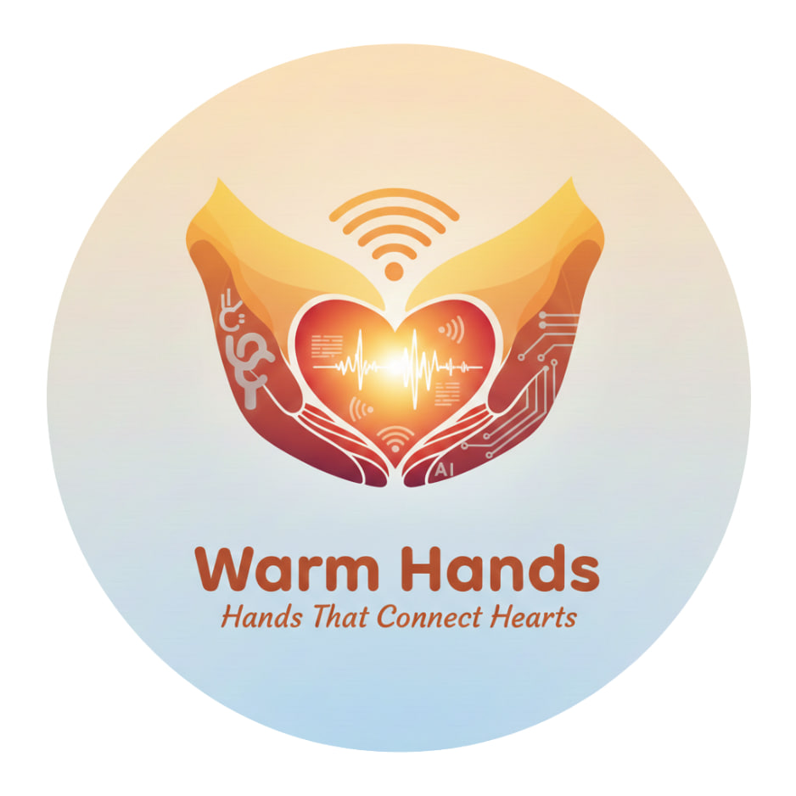

Presented By
Fantastic 3

Table of Contents
Titles Page No
1. Target audience/beneficiaries 1
2. Problem Statement 2
3. AI-Based Solution : Introducing Warm Hands 2
3.1. How the AI works 2
3.2. Why AI is the Right Choice 2
3.3. Responsible & Ethical Approach 2
4. Feasibility 3
5. Scalability and Impact 4
6. Outreach Plan 4

- Target audience/beneficiaries
The primary target audience includes patients who are deaf, hard-of-hearing or speech-impaired and healthcare providers such as doctors, nurses, and medical administrative staff in Myanmar. This system acts as a tool to bridge the gap between the deaf/speech-impaired and healthcare providers who do not understand Burmese traditional sign language.
A secondary target audience can be institutional beneficiaries wanting to learn basic Burmese sign language hand gestures that are included in the emergency and healthcare domain.
- Problem statement
In Myanmar’s healthcare system there is a problem. Medical professionals and patients who are deaf, hard-of-hearing, or have trouble speaking, do not communicate well. When these patients go to a hospital, they have a hard time telling doctors about their symptoms, and doctors and nurses do not know sign language. This makes it difficult to understand what is wrong without an interpreter, who is hard to find. This communication problem can be dangerous for patients and shows the need for a better way to communicate.
The system is mainly going to address Stronger Communities focus area of Google.org, more specifically to strengthen the relationship and communication between healthcare professionals and deaf/speech-impaired patients. Our system ensures equal healthcare services by implementing AI to translate Burmese sign language to text/voice in real time and vice versa.
This issue is critical because the deaf and speech-impaired community have restricted access to basic human rights such as healthcare. There are little to no Myanmar Sign Language datasets, so our system will collect data from the community. It also transforms Burmese speech or text to 3D animated sign language and translates signs to speech or text, ensuring no patient is left unheard or unseen.

- AI-Based Solution: Introducing Warm Hands
  - How the AI Works
- The Patient’s Voice: We use Google Media Pipe to track 21 3D hand signs of the patients and face expressions in real-time. This skeletal data is processed by an LSTM neural network trained on Myanmar Sign Language (MSL) medical terms, turning a patient's signs into clear text for the doctor.
- The Doctor’s Guidance: We use the Google Cloud Speech-to-Text API to detect what the doctor is saying in Burmese. Then we instantly translate it into a visual format where a 3D avatar (rendered via Three.js) performs the signs back to the patient.
  - Why AI is the Right Choice
Sometimes doctors need to communicate with patients at night. It is hard to find someone who can interpret. The AI is always available so doctors and patients can communicate in an emergency. Even when patients are in pain or distress, they often communicate important information with sign language rather than speech. Our AI captures and interprets these signs in time, ensuring doctors receive a more completed patient’s condition and provide more safety and more carefulness.
  - Responsible & Ethical Approach
- Privacy by Design: We know that medical information is private. Our system translates conversations in real time and does not save any videos or audio. This way, what the doctor and patient talk about stays private.
- Restoring Autonomy: This solution helps patients communicate with their doctors directly about their health without needing a family member to translate. This makes patients feel more in control of their healthcare, especially during difficult times.

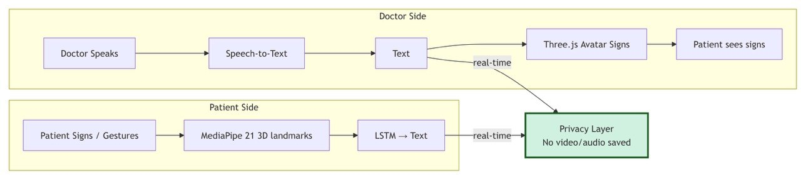
Figure: System Workflow Flowchart of How Warm Hands Works
- Feasibility
To make sure Warm Hands is a solution for the healthcare sector in Myanmar, we have a plan to make it work. We want to make sure it is realistic. We use our resources in a smart way.
We made sure the app is not too big so it can run on the tablets and smartphones that hospital staff already use. This way, hospitals do not have to buy expensive equipment. We do not have a lot of data on Myanmar Sign Language so we will use something called Transfer Learning. We will use models that already exist and add our data to make it work better. We plan to record over 100 medical signs like "pain level" and "emergency".
We will work with Deaf Community Organizations to make sure the 3D Avatar signs are correct and easy to understand. We will talk to volunteers to make sure the instructions are clear and simple. We are students at Myanmar Institute of Information Technology (MIIT) so we have access to computers and mentors who can help us with the AI and software.
Month | 1 | 2 | 3 | 4 | 5 | 6 | 7 | 8
Phase 1: Foundation | UI/UX + MVP Development
Phase 2: AI Training |  |  | MSL Recognition + Data
Phase 3: Validation |  |  |  |  | Clinical Demo + Bug Bashes
Phase 4: Launch |  |  |  |  |  |  | Final Testing + Deployment

Table: Warm Hands Project Timeline
- Scalability & Impact
The Warm Hands system is made to grow and reach people. First, we are focusing on hospitals. The system is designed to be flexible. This means we can easily add things to it. We can add words to the system and make new modules for things like law, schools, and public transportation, so the app can be used in daily life. We can also make the system work in areas. We are starting with Myanmar Sign Language and can collect data from other places to support other sign languages in Southeast Asia.
The system is also flexible in how it can be used. We can use it on phones or on computers in public places like hospitals, information desks, and government offices.
In the community, the Warm Hands project helps people feel like they belong. Deaf and speech-impaired people can communicate with doctors without needing someone to interpret for them and keep their things private. In the country, Warm Hands helps make the healthcare system better and fairer by reducing mistakes caused by communication problems and showing how technology can solve problems. In the region, the Warm Hands project is a model for using technology to make things more accessible and to help people who do not have resources.
We want to make sure that every person can communicate and be heard. The Warm Hands system is made to help people in Myanmar and to make the world a fairer place.
- Outreach Plan
To make people understand what AI is and to get more people to use it, we want to talk to at least 1,000 people through a campaign called "AI for Accessibility."
- Live "Experience Booths" (Target: 400+) - We will set up booths in hospital waiting areas and the school campus where people can try out AI. Tablets will let staff and patients talk to an app and see an Avatar sign in real-time, helping people trust AI as a tool.
- "AI for Inclusion" Seminars (Target: 300+) - We will have seminars for medical students and healthcare workers to teach them about AI. We will explain how Computer Vision works, like an "eye" that understands gestures, to reduce fear and show how AI can help their jobs.
- Social media Awareness (Target: 300+) - We will make videos and share them on Facebook and Telegram. These will show how we are training our AI model to understand Myanmar Sign Language and collecting data from our community to encourage people to take part.
- Peer-to-Peer "Ambassadors" - We will ask 20 student volunteers to spread the word about AI. Each will show our app to 10–15 people to reach outside the technology community.
We will measure success by counting how many people come to demos and using a simple survey to see if people feel more comfortable with AI after learning and trying it out.

